Famous Video Games

What do these games have in common?

Pong -2D top view



Pac-Man - 2D top view


Tetris - 2D side view
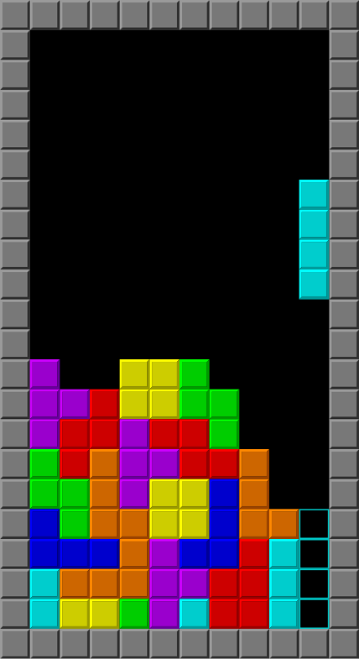

Angry Birds - Side View
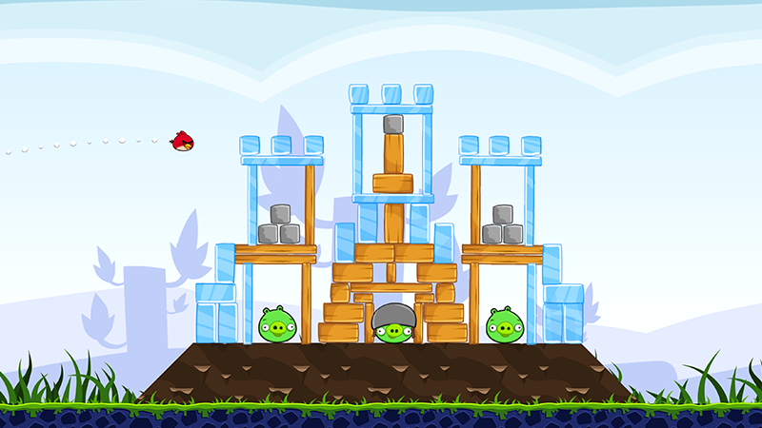

What do these games have in common?

Minecraft - First person 3D
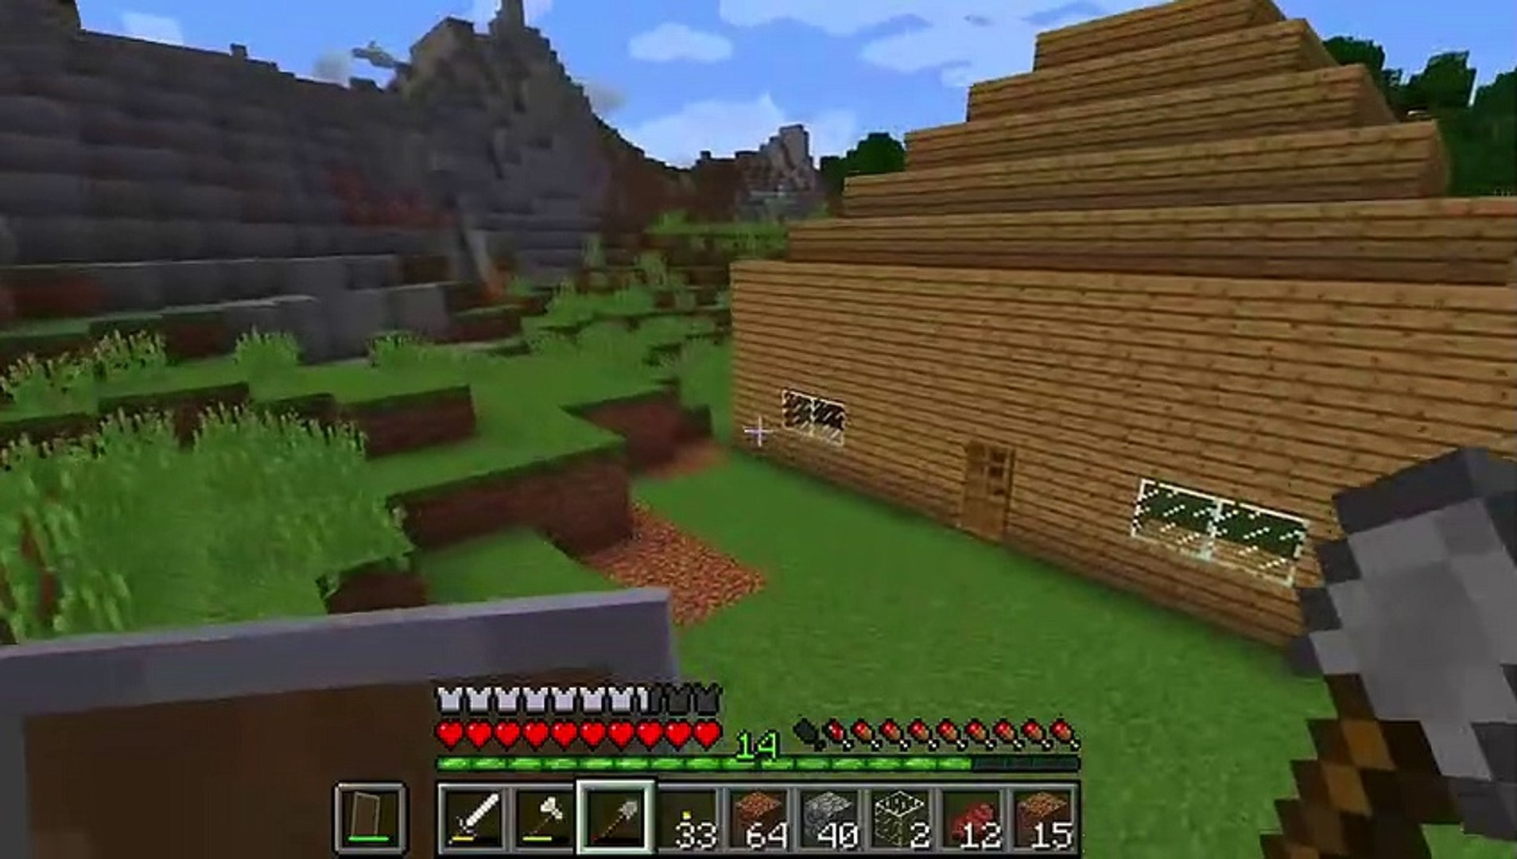

Fortnite - 3D With Camera behind player
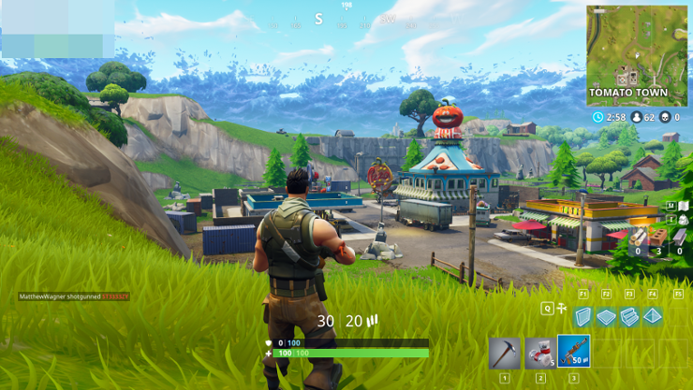

Overwatch - First Person 3D
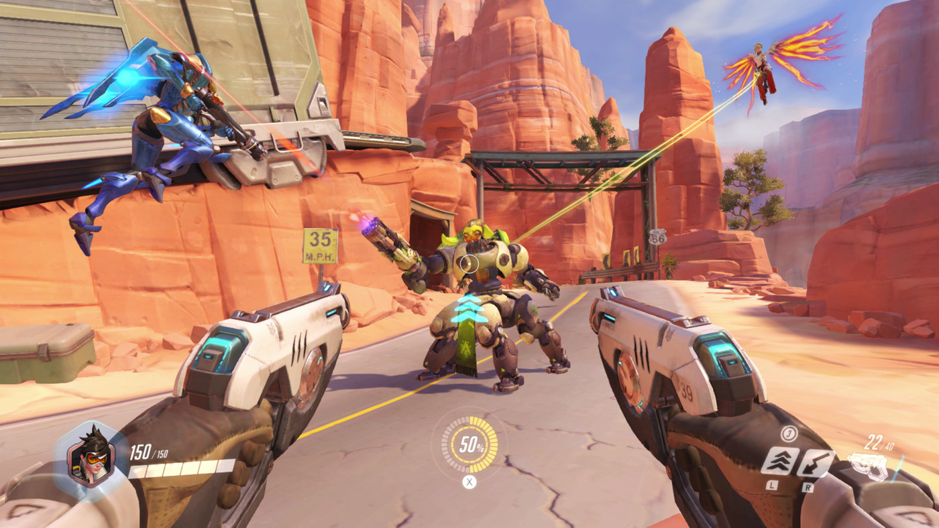

Some Sources Learning
- https://www.geeksforgeeks.org/how-does-a-computer-render-3d-objects-on-2d-screen/
- https://en.wikipedia.org/wiki/3D_projection
- https://www.youtube.com/watch?v=U0_ONQQ5ZNM
- https://gamedev.stackexchange.com/questions/147024/why-are-3d-projections-on-a-2d-screen-not-like-what-the-human-eye-sees

